FundsAtWork insurance benefits
Acceptance of quotation and installation documentation

Name of employer

Checklist for installation information
Document | Signed / initialled by |  | Completed by | Compulsory | Page | 
Sections on installation form
Employer details |  | MD, FD or authorised signatory of employer | Employer or Broker | Yes | 2
Broker details |  | N/A | Broker | Yes | 3
Take-over of existing insurance cover |  | MD, FD or authorised signatory of employer | Letter from existing underwriter | Yes – if applicable | 5
Insurance premium collection |  | Authorised signatory on bank account | Employer or Broker | Yes | 5
Mandatory additional documentation and annexure
Acceptance of FundsAtWork quotation (quotations are valid for 3 months). If quotation has expired please re-quote |  | MD, FD or authorised signatory of employer | Employer | Yes
Copy of employer’s certificate of registration or any other official document that proves the existence of the employer eg if school then a registration certificate or letter from the department of education showing school’s registration number |  | N/A | N/A | Yes
Cancelled cheque or letter from the bank on the bank’s letterhead |  | N/A | N/A | Yes
Copy of letter appointing broker |  | MD, FD or authorised signatory of employer | N/A | Yes
Broker (key individual) accreditation from FSB website |  | N/A | N/A | Yes
Member data in MS Office Excel format |  | N/A | Employer | Yes

Acceptance of quotation and installation documentation

Name of employer

Start date |  |  | - |  |  | -

- Please submit this form together with all supporting documentation and membership data to fawquotes@momentum.co.za before the inception date of the scheme.
- If the data provided by the employer at installation differs by more than 25% from the data on this accepted quote then Momentum will do a re-costing and inform the employer accordingly.
- If the employer changes the benefit structure at installation, the scheme will be installed as per the accepted quote. A re-quote will then be prepared and the applicable changes will only be made in the following month.

Quotation number

Version number

Benefit structure number

Employer duly authorised signatory and employer details
By signing this quotation you, the employer, are confirming that you have read, understood and accept all the conditions of the booklet entitled “Your FundsAtWork insurance benefits quote in detail” as it applies to your proposed insurance benefits and that you have been fully appraised under the Disclosure in terms of the Financial Advisory and Intermediary Services Act (the FAIS Act).

Insurance policies will be prepared based on this acceptance.

Name of employer

Please attach copy of registration certificate

Type of legal entity

(State whether CC, Ltd, (Pty) Ltd, Trust, Association, etc)

Physical address

Postal code

Postal address

Postal code

Contact person (full
name)

Title

Email address

Telephone number

Fax number

Please note that only the managing director or financial director of the employer may sign here. Alternatively the managing director or financial director may appoint an authorised signatory.

Name

Designation

Signature

Date

Broker details
Broker / Agent code

Contact person

Broker / Agent name

Broker house

Broker house code

Reference No (ABSA &
FNB brokers only)
Physical address

Postal code

Postal address

Postal code

Email address

Cellphone number

Do you have a Momentum contract? | Yes |  | No

Have you received the letter for | Yes |  | No
the FundsAtWork website registration?

Are you in service with Momentum? | Yes |  | No
If out of service please contact your marketing adviser as soon as possible.

Broker signature

Momentum Distribution Service — Marketing adviser
Name

MDS branch

MDS adviser code

Production credits |  |  |  | %

Date

Marketing adviser signature

Initials of the signatory
ie MD or FD or authorised signatory of employer

Momentum Distribution Service — Specialist marketing adviser / Business development manager
Name

MDS branch

MDS adviser code

Production credits |  |  |  | %

Date

Specialist marketing adviser / Business development manager signature

Delivery details
All communication (insurance policy documents and member packs) will be emailed / delivered to the employer’s address (as shown on page 2). If this does not apply please indicate below where these documents must be sent to:

The marketing adviser |  | The broker |  | (address as on page 3)

If the marketing adviser please provide internal code

The Financial Advisory and Intermediary Services Act No. 37 of 2003 (FAIS)
The main objectives of the FAIS Act are as follows:

• to create a regulatory framework which ensures the protection of the consumer;
• to make sure that consumers are given sufficient information to enable them to make informed decisions;
• to regulate the selling of financial products and the advice-giving activities of financial services providers and their representatives.

The legislation applies to any person (both natural and legal) that falls within the definition of a financial services provider or a representative who gives advice or provides an intermediary service in respect of a wide range of financial products to members of the public. This includes financial products such as securities, participation in collective investment schemes (eg unit trusts), insurance contracts, and benefits provided by pension funds and medical schemes as well as investments in foreign currency and deposits.

Anniversary month

Please note that this is the month that benefit statements are issued. The premiums for the insurance benefits are reviewed in July of each year.

Initials of the signatory
ie MD or FD or authorised signatory of employer

Take-over of existing insurance cover

Where existing insurance cover is being taken over from another underwriter it is essential that the underwriter provides us with the detail requested and that this section is completed in full to ensure that no members are prejudiced by the take-over. Subject to Momentum’s free cover limits and policy terms and conditions, the cover of the members actively at work in the existing arrangement will be taken over.

Name of previous fund / scheme

Underwriter

Please attach the letter from the previous underwriter on their letterhead showing the accepted covers including any terms and conditions.

If the letter is not attached at installation stage then the free cover limit as quoted will apply.

Are there members in receipt of disability income benefits? | Yes |  | No
If yes, please add these members on the installation data template indicating that they are disability claimants.

Insurance premium collection

Insurance premiums will be collected from:

Bank

Branch name

Branch code

Account number

Account name

Current |  | Transmission |  | Savings

Preferred deduction day *

Date of first collection

* Deductions may be done on any pre-defined day during the period from the 15th up to the 5th of the following month.

Please attach a cancelled cheque or a letter from the bank, on their letterhead, confirming the bank details.

I hereby grant Momentum authorisation to collect the insurance premiums after they have been confirmed, from the abovementioned account:

Name

Designation (authorised
signatory on bank account)

Signature

Date

Name of employer

Employer portal details
The employer portal enables each employer to control the monthly insurance premium and claim processes. The employer will be able, amongst others, to add new members, transfer members between branches, inform Momentum when members leave and provide Momentum with the necessary automatic fund transfer instruction each month.

There are three levels of access on the employer portal: change, 2nd authorisation and view. The designated signatory of the employer authorises the level of access that each user will have and also indicates which pay point the user must have access to.

2nd authoriser facility

After the changes have been loaded, the 2nd authoriser will confirm the claims loaded and / or the premiums that will be collected from the bank account via the automatic fund transfer facility. If you require this functionality, please add the 2nd authoriser below. Please note that this is not a compulsory function.

 | User 1 |  | User 2 |  | User 3 |  | User 4
Title, first name and surname
ID number
Level of access |  | All changes |  | All changes |  | All changes |  | All changes
Level of access |  | View only  2nd authoriser for claims  2nd authoriser to confirm contributions |  | View only  2nd authoriser for claims  2nd authoriser to confirm contributions |  | View only  2nd authoriser for claims  2nd authoriser to confirm contributions |  | View only  2nd authoriser for claims  2nd authoriser to confirm contributions
Pay point
Email address (more than one user can’t have the same email address)
Contact number
Existing user ID
Instruction | OR | Grant access | OR | Grant access | OR | Grant access | OR | Grant access
Instruction |  | Remove access |  | Remove access |  | Remove access |  | Remove access

Please note that if the employer has more than one pay point, a user for each pay point needs to be authorised to have access.

The designated signatory of the employer must notify Momentum in writing if there are any changes to the level of access, as specified in the table above. This includes notification if any user’s access needs to be removed.

Please note that only the managing director or financial director of the employer may sign here. Alternatively the managing director or financial director may appoint an authorised signatory.

Please note that only the managing director or financial director of the employer may sign here. Alternatively the managing director or financial director may appoint an authorised signatory.

Name

Designation

Signature

Date

Name of employer

Employer portal details (continued)
The authorised users will be provided with login details (Webname and User ID). The user will then need to phone the client contact centre on 0860 65 75 85 to set up a Pin (personal identification number). It is imperative that the login details and the Pin are treated with the utmost confidentiality. If the login details and / or the Pin are shared or compromised in any way, Momentum will not be held responsible for any unauthorised use.

Please note that all transactions and changes made by the authorised user will be updated automatically after submission. Momentum therefore will not be held liable for any processes / transactions / changes resulting from any incorrect submission.

We require this information for each pay point; please complete this section for each pay point if more than one.

The contact person at the employer will be the only person from whom we will accept instructions for this pay point and who will confirm the contributions every month. Please ensure that the contact numbers are secure, as confidential information will be sent to these numbers.

Pay point number

Pay point name

Contact person (full name)

* Reminder date

Email address

Telephone number

Cellphone number

Fax number

Physical address where training
must take place

Postal code

* Reminders will be sent to the person shown above (one user per pay point) via email if no authorised user has accessed the employer portal in respect of the monthly reconciliation process by the reminder date (preferably 5 days before the contribution collection date) specified above.

Please note that only the managing director or financial director of the employer may sign here. Alternatively the managing director or financial director may appoint an authorised signatory.

Name

Designation

Signature

Date

Name of employer

Employer portal terms and conditions

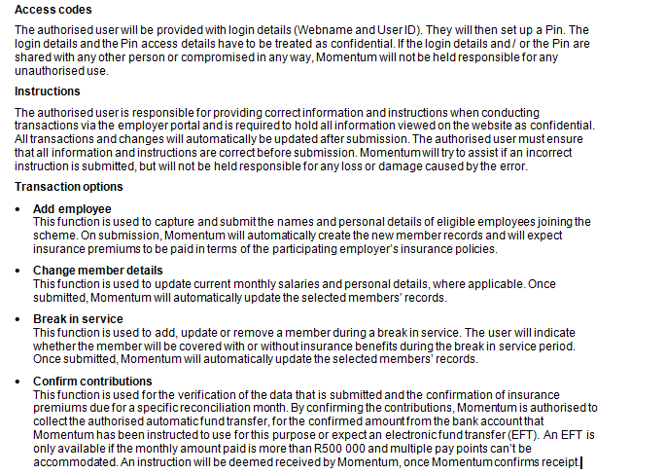
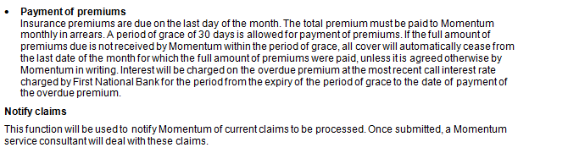

Please note that only the managing director or financial director of the employer may sign here. Alternatively the managing director or financial director may appoint an authorised signatory.

Name

Designation

Signature

Date

